System Design Diagrams

**(All diagrams are made on draw.io and online.visual-paradigm.com)**

**Iterative Refinement Model**

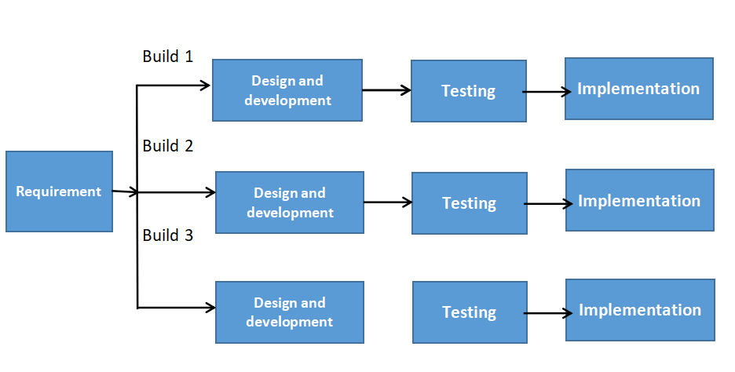

**Component Diagram**

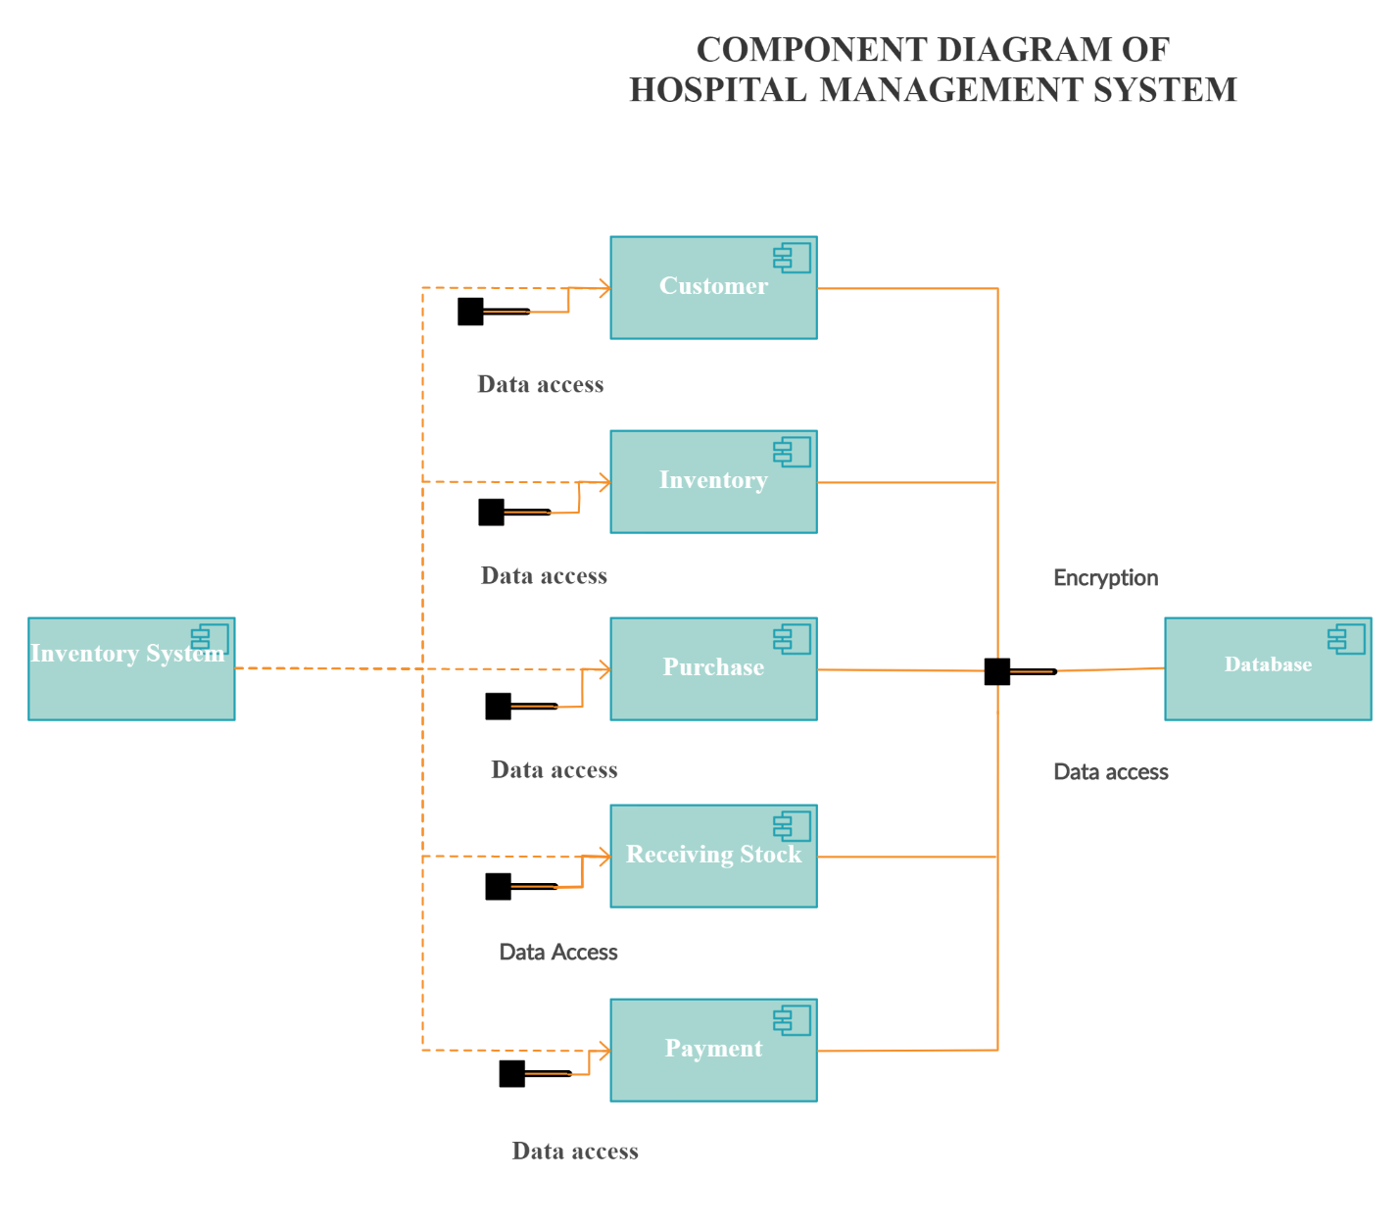

**Deployment Diagram**

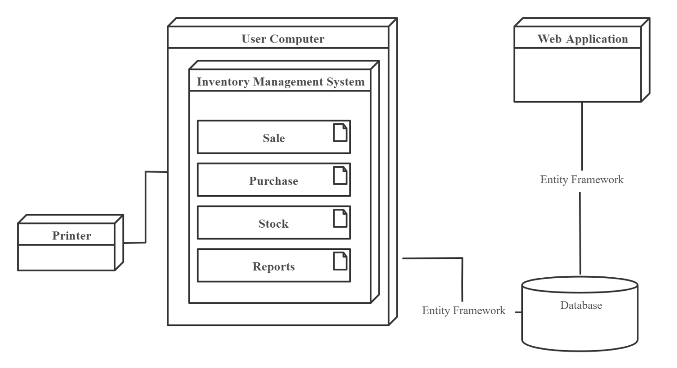

**Context Diagram / Data Flow**

